**How to add a new indicator**

**QT designer – checkBoxRSI**

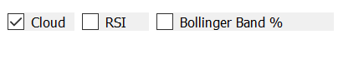

**QT Designer**

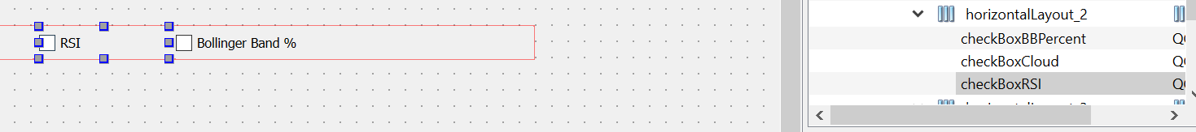

**Config Tab - Add Daily and Weekly**

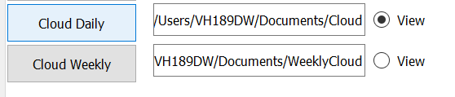

**Runmain.py**

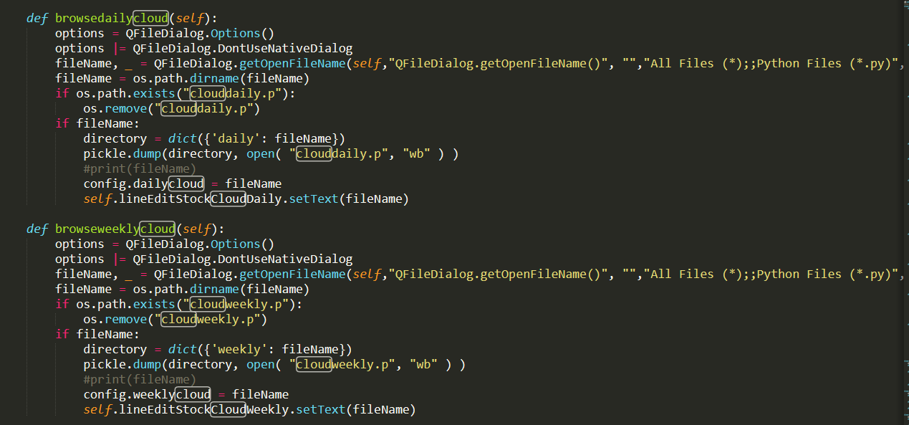

**Indicatorfunctions.py**

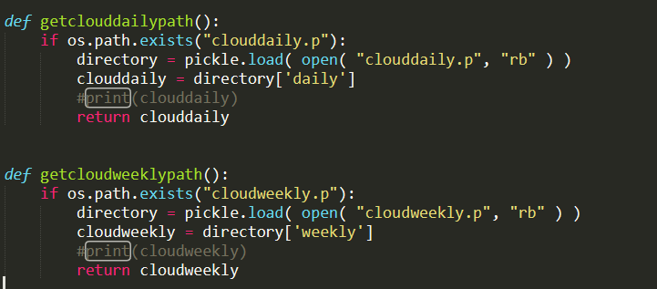

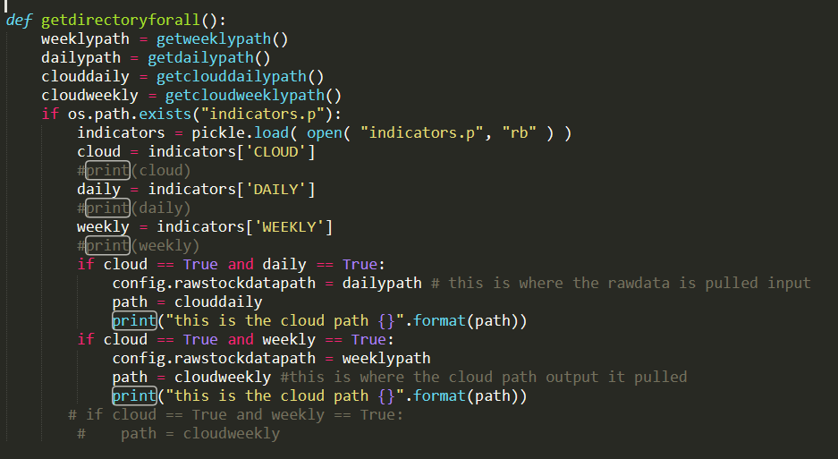

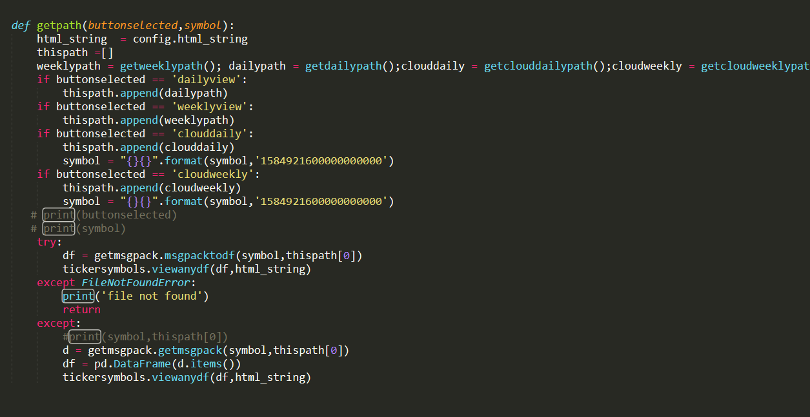 **This is the actual indicator** *** **This is the actual indicator** ****

**GetCloudMultiThread.py**

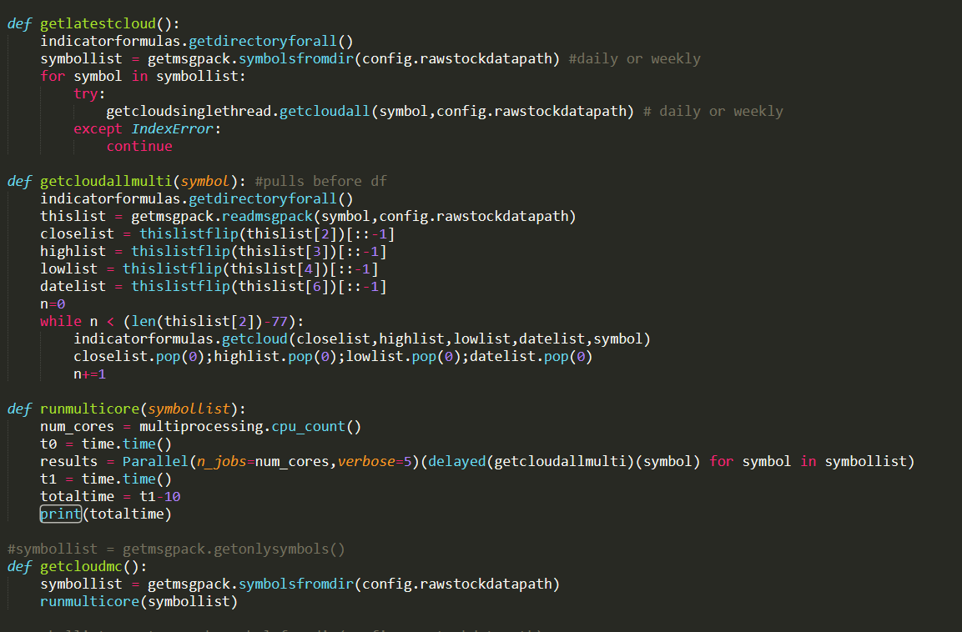

**GetCloudSingleThread.py**

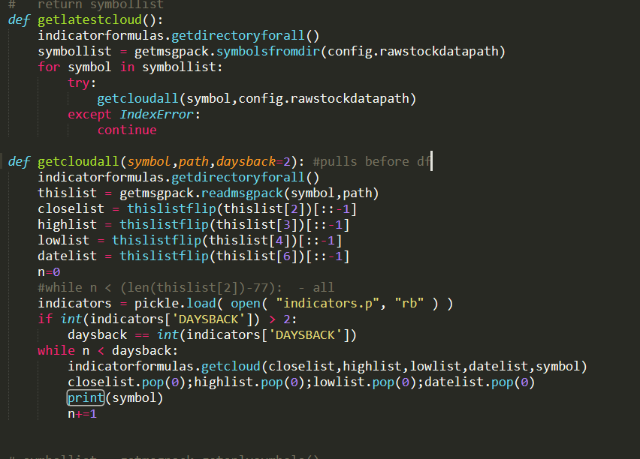

**Runmain.py**

